**Mambo**

**Summary**

Mambo music, which emerged in Cuba in the 1940s but was popularized in Mexico City and New York, blended jazz harmonies and instrumentation with Afro-Cuban rhythms. Mambo dancingevolved in New York City in the late 1940s and became an international dance craze by the early 1950s. The dance was based on the Cuban *son*, with the addition of turns borrowed from American swing dancing, and solo dance steps adopted from Cuban rumba, Puerto Rican *bomba*, and African-American jazz. The dance emerged through the intermingling of these traditions in New York’s dance halls, especially Harlem’s Park Palace/Plaza and the Palladium Ballroom. Jewish resorts in the Catskills provided economic capital to sustain and disseminate the form by employing dozens of mambo bands and dancers every summer. The source of both mambo’s scandal and its appeal were the sensuality of the dance and the unpredictability of its improvisational solo steps. Mambo dancing evolved into salsa dancing in the 1970s and later experienced a resurgence of popularity in the late 1990s and 2000s during the salsa dance craze. Many New York salsa dancers prefer to identify their dancing as mambo, often drawing on 1950s mambo steps for inspiration.

**Expansion**

Mambo music emerged through the blending of Cuban *son* and *danzón* with American jazz, enabled through modern technological innovations, including sound recordings, radio, and airplanes, all of which facilitated travel and migration of people as well as sound waves. Cultural exchange between New York and Havana was central to the evolution of mambo music, although the genre is commonly believed to have been invented in Cuba. In the late 1930s, two specific innovations in Cuban dance music were pioneered, each one now claimed by different supporters to be the birth of mambo. While playing danzones with Arcaño y su Maravillas, Orestes and Israel ‘Cachao’ López introduced a new sub-genre called *danzón de nuevo ritmo* (or *danzón mambo*), often identified as the first mambo rhythm. Concurrently, Arsenío Rodríguez developed a new section of the Cuban dance genre *son montuno*,which he named the ‘*diablo*’ section, a rhythm that is likewise cited as the beginning of mambo music. Mambo was not recognized as a musical genre, however, until the orchestras of countrymen Damaso Pérez Prado living in Mexico City and Frank ‘Machito’ Grillo living in New York became successful in the late 1940s. It was Machito and his AfroCubans (under the direction of Mario Bauzá), playing at New York’s Latin dance halls throughout the 1940s and 1950s, which had the most significant impact on the evolution of mambo dancing. The dancing developed in dialogue with the music of Machito and his two greatest contemporaries—Tito Puente and Tito Rodríguez.

Mambo dancing evolved through interaction of diverse cultural traditions in post-Second World War New York City, where modern urbanization brought immigrants from disparate parts of the Caribbean, the United States, and Europe into close proximity. Drawing most heavily on Cuban, Puerto Rican, and African-American social dance traditions, New York social mambo dancing of the 1950s was characterized by basic partnered turns interspersed with episodes of improvised solo dancing during which couples released hold entirely. Solo dancing was idiosyncratic, featuring playful footwork highlighted by precise placement of the hands, shimmies of the shoulders, undulations of the torso, and drops to the floor, all designed to express the polyrhythmic texture of the music. Individuality and creativity were highly valued, and women had ample opportunity to express themselves independent of a male partner. The most skilled dancers always danced ‘on two’, lining up their change of direction with the two side of the clave, the rhythmical cornerstone of the music. Mambo borrows its clave (key) rhythm from the son, a pattern extending over two measures, one which accents beats two and three of a four-beat measure (two side), and the other which accents beats one, two and a half, and four (three side). Professional mambo dancing emerged concurrently with social dancing. Many professionals (such as Augie and Margo Rodríguez) incorporated ballet turns and lifts into their mambo routines.

Mambo dancing was prevalent in other major U.S. cities in the 1950s, including Chicago, Miami, and Los Angeles. Outside of New York, most Caucasians learned mambo from ballroom dance studios, whose codification process stripped the dance of the improvisational sensibility and musical interplay that was at its heart. Mambo dancing never became popular in Cuba, although Cubans often danced steps later named cha cha chá to mambo music. Imported to the U.S. as the cha-cha, the new dance, which incorporated two additional short steps into the son/mambo basic, became exceedingly popular in the early 1950s.

Mambo dancing fell out of fashion in the 1960s, although it evolved into salsa and Latin hustle of the 1970s and later resurfaced in the 1990s during the salsa craze. New York-born Puerto Rican Eddie Torres became the most influential proponent of New York mambo dancing in the 1990s and 2000s, his disciples spreading his updated style of mambo/salsa worldwide.

Juliet McMains

**References and Further Reading**

García, D. (2006) *Arsenio Rodríguez and the Transnational Flows of Latin Popular Music*, Philadelphia: Temple University Press.

Hutchinson, S. (2004) ‘Mambo on 2: The Birth of a New Form of Dance in New York City,’ *Centro Journal*, 16.2: 108–137.

McMains, J (2013). ‘Hot Latin Dance: Ethnic Identity and Stereotype,’ in *The Oxford Handbook of Dance Ethnicity*, edited by Anthony Shay. New York: Oxford University Press.

Sublette, N*.* (2004) *Cuba and its Music: From the First Drums to the Mambo,* Chicago: Chicago Review Press.

Thompson, R. F. (2004) ‘Teaching the People to Triumph over Times: Notes from the World of Mambo,’ in *Caribbean Dance from Abakua to Zouk: How Movement Shapes Identity*, edited by Susanna Sloat, 336–344. Gainesville: University Press of Florida.

**Paratextual Material**

Videos

*Latin Music USA*. DVD. Directed by Pamela Aguilar and Daniel McCabe. 2009. Public Broadcasting Services. (Hour 1 is all about the Mambo)

*Mambo Madness.* Film. Directed by Courtney Hafela. 1955.

*Palladium: Where Mambo was King*. TV. Directed by Kevin Kaufman. 2002. Bravo.

*The Spirit Moves: A History of Black Social Dance on Film, 1900-1986.* DVD. Directed by Mura Dehn. 1987; Dancetime Publications: 2008. (There are two sections of this that feature Palladium mambo dancers.)

Websites

<http://americansabor.org/musicians/styles/mambo>

<http://www.pbs.org/wgbh/latinmusicusa/#/en/exp/mambo/universe>

Images:

1) Image of unknown dancers inside the Palladium. Getty Images.

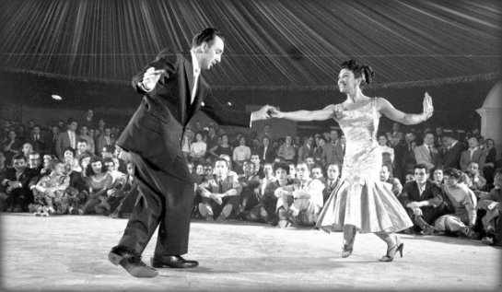

2) Image of Cuban Pete and Millie Donay dancing at the Palladium. The image first appeared in Life Magazine in 1954. It is now owned by Getty (<http://www.timelifepictures.com/source/search/FrameSet.aspx?s=AlternateImagesSearchState%7c0%7c3%7c-1%7c28%7c0%7c0%7c0%7c1%7c0%7c0%7c0%7c0%7c0%7c0%7c0%7c0%7c%7c286338%7c16384%7c0%7c0%7c0%7c0&tag=2>

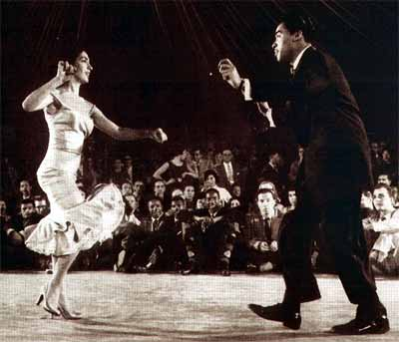

3) There are great images from this article 1953 issue of Ebony Magazine (vol. 9, issue 2, p. 40-48) A pdf of the entire article has been sent as a separate file.

4) An Image of Augie & Margo Rodriguez who became the most successful stage mambo dancers, might also be fun. Here is the email Christine Hamer Hodges who wrote a biography about Augie & Margo Rodriguez: <[cityscoop@comcast.net](https://mail.uvic.ca/owa/redir.aspx?C=k639XbD2xkGkcb2siyxBJz6HTaQh6dAIPLFma9BJHBrZOuWXIvHwlujIMNme9wFoXQLKmFLISYg.&URL=mailto%3acityscoop%40comcast.net" \t "_blank)>  She might know who owns the copyright.

